*Manuscript Tracking #* 16-12-220-3M

An Emoji is Worth a Thousand Variables

Tony McCaffrey and Percival G. Matthews

Author Note

Dr. Tony McCaffrey, [tmccaffrey@eaglehill.school](mailto:tmccaffrey@eaglehill.school), teaches math at Eagle Hill School in Hardwick, MA. He is also the CTO of Innovation Accelerator, Inc., which has developed the online BrainSwarming platform for group innovative problem solving. Percival Matthews, pmatthews@wisc.edu is an Assistant Professor of in Educational Psychology at University of Wisconsin-Madison. His research is dedicated to understanding more about the ways students learn about numbers, with a special emphasis on ratios and fractions.

Abstract

In this piece, we discuss a teacher’s success using icon-based equations to promote mathematical thinking and learning in his Algebra I classrooms. We further offer some speculative hypotheses – based in cognitive science research – explaining why these icon-based equations are more accessible for many students when compared to formal algebraic notation and suggest ways to use the icon-based representations to scaffold thinking and performance with formal notation.

*Keywords:* Algebra, Reasoning/Sense Making, Mathematical Practices

How can I make algebra more meaningful for students? How might I make it appear to be more useful? These are the sorts of question that many Algebra teachers have asked themselves. These questions are obviously important given that Algebra serves as a gateway not only to higher mathematics, but into higher education more generally (Moses and Cobb 2001). However, it is one thing for teachers to know about its importance and another thing entirely to get students to engage with Algebra in meaningful ways.

In this piece, we discuss the potential of the icon-based mathematical games Emoji Math and Mobile Math to promote student engagement with and understanding of Algebra. We describe how these games serve as an accessible entry point for Algebraic thinking; in contrast to traditional symbolic algebra, the use of these icon-based games appear to be more meaningful to many students. Because the games correspond to symbolic Algebra, we suggest that they may serve as a powerful bridging function for fostering children’s understanding of symbolic algebra in typical classrooms.

One path to making Algebra more meaningful is using students’ informal experiences to build formal math knowledge. Although teachers are encouraged to build on students’ experiences (CCSSI 2010), we are often offered little in the way of practical suggestions to guide us. With this in mind we offer vignettes from Michael McCall’s grade 10 Algebra I classes that we believe serve as instructive examples. Notably, the examples we share were initially presented not by the teacher, but by the students! Fortunately, these examples proved both to be engaging and to be well-aligned with foundational Algebra I skills.

**EMOJI MATH – A WAY TO ENGAGE STUDENTS’ INFORMAL EXPERIENCES**

Michael has long encouraged his students to bring mathematical games and puzzles to class to facilitate mathematical discussion. One day, a 10th-grade student wanted to share a puzzle he found online, called emoji math, illustrated in Figure 1a below. Two things about the puzzle were immediately noteworthy: First was the fact that the puzzle is an algebra puzzle in disguise! When the student who introduced the puzzle was asked more about his thoughts, it was clear that he saw it as a number puzzle but did not conceive of it as an Algebra problem at all! Second, as Michael observed all his classes grappling with the task, he realized almost all students could solve it – and most could solve it in their heads. He later found that even a few third- and fourth-grade students who participated in his summer classes could reason their way through it, though they were years away from taking Algebra class.



**Figure 1.** (a) The Emoji Math problem submitted by Michael’s student. This problem used emojis in place of variables to represent algebra problems. (b) The formal version of the same problem using traditional letter variables instead of emojis (solution is at the article’s end).

In a picture of stark contrast, Michael found that almost all of his high school students who could solve the puzzle in Figure 1 could not solve the equivalent algebra problem below (Figure 1b). What was happening? When asked, students suggested that the food pictures (i.e., emojis) “make sense” whereas the variables do not. The food pictures somehow made the problem concrete enough so that the students felt they were reasoning about a real situation rather than just manipulating symbols until they got symbol sequences in the form *x = 20, y = 5,* and *z = 1*. The nature of the problem made it both engaging and accessible. Still, the emoji and symbolic versions were mathematically identical.

This difference in performance underscores the limits of formal Algebra for promoting student thinking. That is, formal algebra is not easily understood by a large subset of students, because it is too far removed from their experiences. It appears that these students often need things just to be a little more connected to their concrete experiences so they can gain initial traction towards algebraic understanding. To those readers who may be reluctant to embrace these icon-based games, who might feel that techniques using emoji and cartoon mobiles “dumb down” the mathematics, we point out that the emojis in Figure 1 really *are* variables. They are simply pictures instead of letters. The price of tacos varies from restaurant to restaurant; the price of tacos really is a variable! In this sense, emoji math is not watered down algebra, it’s just algebra that uses variables that students are more likely to encounter in life outside the classroom.

Indeed, the Algebra represented in Figure 1 is not dumbed down at all. Notice that the puzzle presents a linear system in three variables (i.e., the number of tacos, burritos, and chili peppers). Algebra I students are generally not exposed to 3-variable systems; indeed, when Michael checked all of the Algebra I textbooks available in his school’s faculty library, none included systems of three variables. Since Michael’s students had taken at most Algebra I (and some much less), none of them had ever seen three variable systems before this class. Yet somehow, the puzzle was intuitive enough that most students could solve it.

**INSERT TEACHER TIPS BOX 1 HERE.**

**Box 1. Teacher Tip #1**

**Emoji math is widely available on the web. In fact, mobile phone apps featuring emoji math are available both at the apple store and on Google play. Additionally, students and teachers can easily create emoji math equations using smartphones or laptop computers. Any simple linear equation can be rendered in emoji form. You might try using emoji math in your classroom for any of the following:**

1. **Introducing formal equations from the text to make them more accessible.**
2. **Encouraging students to translate from standard variable format into emoji format and vice versa.**
3. **Comparing your students’ abilities to reason with equations in emoji format versus in standard variable format.**

**Mobile Algebra for a Mobile World**

As it turns out the experience with emoji math was not a fluke. Michael found similar engagement with an even more powerful icon-based algebra system called *SolveMeMobiles*. Imagine using the sort of mobiles that hang above childhood cribs to help students learn about algebraic equations. In mobile math (Figure 2), the balanced horizontal rod represents the equal sign of an equation, and a balanced rod communicates that the icons on each side are equal. The corresponding algebra is to the right of the mobile below.



**Figure 2.** (a) An example of mobile math. The horizontal bar serves as an iconic version of the equal sign, representing equality with the intuitive notion of balanced weights. (b) One symbolic way to represent the same system. Mobiles are flexible in that there are often multiple symbolic ways to represent them.

To solve the mobile in Figure 2, one can reason as follows: If both sides are equal, then 5 hearts and a triangle must weigh the same as 4 triangles. Similarly, because both sides are equal and the total weight sums to 40, we know that each side must sum to 20. These intuitive representations contain identical information to the system of simultaneous symbolic equations in the figure. Working on the right side of the mobile, 4 triangles add up to 20, which means that each triangle weighs 5. On the left, 5 hearts and a triangle weigh 20, which means that 5 hearts weigh 15. Thus, a heart weighs 3. *SolveMeMobiles* offers this visually intuitive way to present, reason about, and solve algebraic equations, and Michael wanted to see how it might support his students’ algebraic thinking.

Michael conducted a small study using *SolveMeMobiles* with 25 teen students in his summer math classes at Eagle Hill School. Every student had previously completed an Algebra I class. Each student worked on four problems: two mobile puzzles and two algebraically equivalent versions that used traditional algebraic variable notation (see Figure 3 for examples). The items presented were problems in three variables and four variables. Importantly, students were not told that the algebraic problems and mobile puzzles were related in any way.

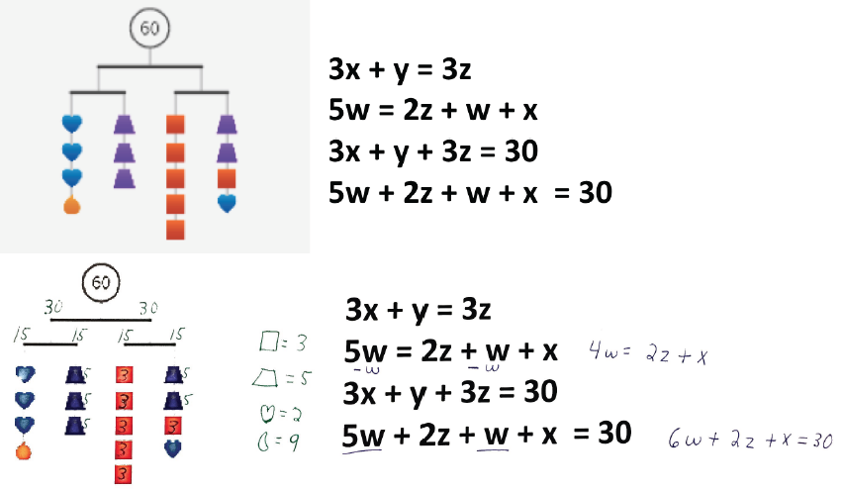

*Figure 3.* Mobile math representing a system in four variables as presented to a student (top panels) and as completed by a student (bottom panels). The work shown here was generated by one student solving the same problem in two alternative formats. When presented symbolically, the student began to manipulate symbols, but was at a loss for how to move forward. In contrast, the mobile representation allowed this student to do most of the work in her head. In general, mobiles allow students to see equivalence relations more clearly so that they could more easily ascertain which variables could be set equal to particular number values. This realization allowed the student to find specific values for the trapezoid (z) and square (w), which could then be substituted in to find the values for other variables.

The mobile in Figure 3 above uses four variables, and there are multiple valid ways to translate it into a set of symbolic algebraic equations. Indeed, one of the advantages of mobile math is this flexibility – a given mobile can often be reused to represent different sets of equations. Michael chose the above set of equations because they both parse the problem a bit compared to more complex options but still leave plenty of room for student thinking. For instance, this system of four equations seemed less taxing than the following set of three: *3x + y = 3z, 5w = 2z + w + x,* and *3x + y + 3z + 5w + 2z + w + x = 60.* At the same time, it required more student work than four equations that are all equal to 15 (i.e., *3x + y = 15, 3z = 15, 5w = 15, 2z + w + x = 15;* see Teacher tips box*)*. The rationale was that these equations would give students too much assistance. The mobile above requires that students reason that each strand of shapes adds up to 15 without giving this information directly.

**INSERT TEACHER TIPS BOX 2 HERE.**

**Box 2. Teacher Tip #2**

**You can take advantage of the flexibility of *SolveMeMobiles* and adapt the difficulty of the problem to suit the needs and skills of your students. For the example in Figure 3, we could have chosen to create four algebra equations that each equaled 15:**

**3x + y = 15**

**3z = 15**

**5w = 15**

**2z + w + x = 15**

**This choice could help illustrate the facts that all four equations were equal, which determines their value given that the four sum to 60. This step breaks the problem into a more digestible form and might be used with beginning or struggling students to help highlight key aspects of the problem. Michael chose a version of the task that was more difficult in order to inspire deeper analysis on the part of the students.**

The results paralleled the findings with Emoji Math: Students successfully solved 91% of the mobile puzzles. In contrast, students were only successful on 18% of the symbolic versions of those same mobile puzzles. Because each student solved both types of problems, this simple study provides solid evidence that the mobiles were easier for students to solve compared to their formal algebraic counterparts. Moreover, as with emoji math, the mobile math puzzles involved 4-variable systems of equations, which are well beyond the 2-variable systems to which students are exposed in Algebra I. Students who had no formal experience with a 4-variable system were able to solve them using mobiles, whereas only 18% of students were able to extend their Algebra I knowledge of 2-variable systems to solve a 4-variable system when it was presented in the traditional manner.

**Reflecting on the benefits of non-traditional symbols**

The results of these small studies suggest that students show more competence navigating complex algebraic relations through mobiles and emojis than through traditional algebraic notation. This is no small point: regrettably, it appears that standard algebra notation can actually act as a hindrance on the path to understanding algebraic relationships. Traditional algebra notation is certainly a powerful tool for those who have acquired a baseline level of understanding. However, it does not appear to be effective for many students. But why? We offer some speculative thoughts below.

Humans are highly visual organisms, and as such, our brains can efficiently process the information represented by the visual mobiles. In contrast, strictly symbolic processing engages language and activates different brain areas than a visual scene, thereby leveraging different modes of thinking. For example, because mobile math visually presents hanging weighted objects, this may trigger the “physics engine” of the brain (i.e., premotor cortex and the supplementary motor area) that performs mental simulations to try to predict how the mobile will act (Fischer et al. 2016). Will it stay balanced? What will send it out of balance? This intuition about balance can inform more symbolically mediated thinking, such as realizing that the first two branches of the mobile in Figure 1 must therefore weigh 30 each. In contrast, standard algebra equations would not induce such mental simulations. For many students, the equal sign in an algebra equation does not offer a dynamic feeling of precariously maintaining the balance of an equation. To many students, the equal sign simply means to add up all the numbers as the problem is read from left to right (McNeil 2014). Because algebraic variables don’t appear to be numbers, even this impoverished version of the equal sign may not seem sensible. Mobile Math, like Emoji Math discussed above, taps intuitive meaning while traditional symbols are often devoid of meaning.

**Connecting Mobile Algebra with Formal Algebra Notation**

The world “speaks” formal algebra using typical notation, so this presents us with an obvious question: if students become proficient with iconic systems like Mobile Math or Emoji Math, how do they transfer their skill over to the standard notation? Michael found that if he consciously integrated elements of formal symbol manipulation into lessons with iconic systems, he could lead students to more proficiency than with formal symbols alone.

The student, Heather, whose work is featured in Figure 4 provides an illustrative example. After Heather worked up to solving 3- and 4-variable mobiles, Michael worked to help transition her to using traditional algebra notation. For example, for the problems in Figure 4, Heather first solved the problems reasoning with the mobiles alone. Then, she was instructed how to transform the mobiles into a system of equations – with one equation for each strand of shapes – using formal notation. As shown in the figure, the student used more formal operations with shape-variables to solve the strand that used a single variable (i.e., solved for the value of a circle). Heather then substituted that value into the next equation in order to find the value of the trapezoid shape. All the while that she was working through the traditional notation, the mobile was present to ground her reasoning. This was a classic example of concreteness fading: starting with a meaningful concrete version and slowly substituting in more abstract elements over time (Fyfe, McNeil, Son, and Goldstone, 2014). Note that the substitution performed for the problem on the right side of Figure 4 is not perfect. The substitution of the value 4 for the teardrop shape is incorrectly indicated as though it were a coefficient for multiplying the value of a teardrop by 4. These glitches are to be expected as part and parcel of the learning process. It is interesting, however, that the solution afforded by the intuitive mobile representation can be used to return and interrogate such notational errors.



Figure 4. Heather first solved the concrete mobile forms and then converted these representations in to a semi-formal symbolic format, using shapes as variables instead of letter variables. In this way, Michael helped students transition from concrete to more formal representations. Note: The symbol of a circle with an X through it is a convention used in class to denote a circle shape as variable and is meant to prevent confusion with a symbol for zero.

Heather and her classmates then learned to transition to using letter variables such as the letter *h* to stand for a heart instead of drawing a heart and later to use the more typical *x* and *y* in place of mnemonic variables. These students then went on to work with fractions in their equations by starting with mobiles with images of half a heart or even one fourth of a heart, for example. They also learned to work backwards: given a set of equations, generate the corresponding mobile.

One consistent observation is that the students respected the horizontal rod of the mobile as an indicator of equality, which seems significant given past research indicating the critical role of understanding the equal sign in algebra problems (e.g., Kieran, 1981). The physical resemblance of a level rod to a balanced system was strong for these students. An uneven rod meant that the two sides were out of balance and thus unequal in the values of their weights. Michael observed that the strength of the association between a level rod and equality of the two sides was much stronger than the presence of an equal sign within an equation. Students made significantly fewer errors around maintaining equality on both sides when manipulating the mobile than when manipulating the two sides of an equation.

The intuitive nature of equality of both sides of a mobile is exemplified by using the mobiles to initially learn simplification of equations. Panel a) of Figure 5 shows a mobile that initially weighs 30 overall and, since the rod is level, is balanced on both sides. Panel b) shows several steps in one image. First, the equation *3h + 1t = 2t + 1h* shows the equality expressed by the balanced mobile. Second, both sides possess at least one triangle, so one triangle from each side can be temporarily eliminated without affecting the balance of the mobile. This is indicated by crossing out one triangle from each side with a red cross. The corresponding equation is



**Figure 5.** An example of simplification in mobile math. **(a)** The initial balanced system. **(b)** An equation for the system that shows the equality of both sides of the mobile (with *h* standing for hexagon and *t* for triangle). **(c)** Substitution is performed in the mobile after it is determined that 2 hexagons equal 1 triangle.

adjusted to *3h = 1t + 1h,* and the definite weight of the mobile is replaced by a question mark to note that the total value has to have changed given the cancelation of portions. Third, both sides possess at least one hexagon, so one hexagon from each side can be temporarily deleted, which is indicated by crossing out one hexagon from each side with a green cross. The equation is once again adjusted to become *2h = 1t*. Finally, panel c) shows a substitution on the left side of the mobile of 2 hexagons for 1 triangle into the original mobile whose weight/sum is known as 30. This maneuver will not affect the balance of the mobile. In fact, this substitution transforms the left side of the mobile so it is completely composed of hexagons. Now, it is easy to solve the mobile: *5h = 15*, so *h = 3*. Knowing *h =3* and *2h = 1t* means that *t = 6*.

Michael even found a way to incorporate negative numbers and the more general additive inverses of variables into mobiles. In Figure 6, the shapes hanging beneath the horizontal rod are affected by gravity and thus have a positive weight. The shapes floating above the horizontal rod take away weight and thus contribute a negative weight to the strand of shapes connected together by a vertical line. The corresponding equations to the two sides (strands) of the mobile are *2c – 4 = 9* and *3t – 6 = 9*. More generally, when shape variables are moved to the opposite side of the horizontal rod, they serve as the additive inverse of shapes on the other side.

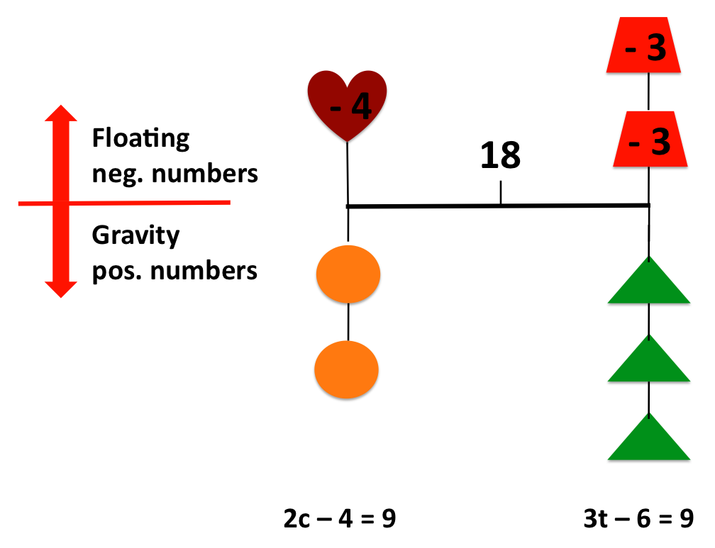

**Figure 6.** Negative numbers in mobiles. The shapes below the horizontal rod are weighed down by gravity and contribute positive weight to the strand of shapes connected by a vertical line. The shapes above the horizontal rod are floating and take away weight thus contributing negative weight to a strand of shapes connected by a vertical line.

Now that substitution and the additive inverse have been introduced, Michael still continues to innovate with the basic mobile notation. Initially, substitution only consisted of replacing shapes by specific number values. However, shapes can also be substituted by other combinations of shapes, as shown in Figure 5. The introduction of the additive inverse considerably expands the power of the notation. For example, Michael is currently working on an intuitive variation on the mobile notation that permits the introduction of adding equations together—as shown in Figure 7. This variation on the mobile notation for adding equations shown in Figure 7 is currently being tested in Michael’s classroom, so there are no results to report at this time. Michael’s ongoing instructional experiment shows the considerable flexibility of the overall mobile notation for visually grounding algebraic operations.

There are, of course, limitations to this approach, as there is no single silver bullet in the educational realm. First, for mobile examples we presented in Figures 2 through 4, at least one arm of an equation could be reduced to an equation in one variable and set equal to a specific number value. It is clearly the case that this is a specialized subset of simultaneous equations. That said, Michael’s work as presented in Figures 5 and 7 is expanding the applicability of mobiles to include a more general class of simultaneous equations. Second, there are some concepts that simply do not translate well to emojis or mobiles. For instance, Michael has been unable to create a good analogue for exponents in the mobile notation. Although he is still



**Figure 7.** New work using icons to represent solution by addition. If *x* is a red square and *y* is a green triangle, then *x + y = 10* can be shown in the first image on the left. Below the horizontal bar are positive elements. The equation *x – y = 2* is represented by the second image. Adding them together produces the third image. Simplification involves crossing out corresponding shapes, as in the 4th image. This results in *2x = 12* and thus *x = 6*.

looking for new ideas, this may present a real limitation of this notation. Perhaps it is ultimately limited to systems of linear equations.

At the end of the day, students certainly need to be able to execute and conceptually understand a multitude of operations using standard algebraic notation. This not in question. That said, iconic systems can help introduce key concepts and make standard versions more meaningful. Michael’s experience was evidence that the icon-based system could serve as an intuitive entry point for algebraic thinking and help bridge the gap to more formal algebraic symbolism. There will be limits to these systems, some due to limits of our collective creativity and others due to inherent limits to the systems. Still, we argue that to the extent that they can help make mathematics meaningful for young learners, they are tools that should be firmly embraced.

Our hope is that researchers and math textbook publishers can eventually collaborate to provide instructional materials that supplement (often impenetrable) formal algebra notation with something more student-friendly. Ideally, publishers would produce materials that tap into children’s intuitive visual abilities using everyday activities that align well with the math content we want them to learn. In the meantime, it is up to educators to make do with what we’ve learned from our introductory courses on human cognition. Fortunately, tools like emoji math and *SolveMeMobiles* can help serve as intermediate steps to scaffold the learning of symbolic algebra. Emoji math can be easily constructed by students using the emojis on their smartphones and is widely available on the web, including in the form of apps for mobile phones. *SolveMeMobiles* is a freely available product of research sponsored by the National Science Foundation. For more information and interactive resources for creating and examining more mobiles, see <http://solveme.edc.org/Mobiles.html>.

**Solution to Emoji Puzzle:**

Taco = 20 = x

Burrito = 5 = y

Hot Pepper = 1 = z

Taco + Burrito + Hot Pepper = 26

**Solution to 60-Header Mobile:**

Purple trapezoid = 5

Red square = 3

Blue heart = 2

Gold raindrop = 9

**References**

Common Core State Standards Initiative (CCSSI). Common Core State Standards for Mathematics. 2010. Washington, DC: National Governors Association Center for Best Practices and the Council of Chief State School Officers. http://www.corestandards.org/assets/CCSSI_Math%20Standards.pdf

* Fischer, J., Mikhael, J., Tenenbaum, J., and Kanwisher, N. 2016. “Functional neuroanatomy of intuitive physical inference.” *Proceedings of the National Academy of Sciences.*

Fyfe, Emily R., Nicole M. McNeil, Ji Y. Son, and Robert L. Goldstone. 2014. “Concreteness Fading in Mathematics and Science Instruction: A Systematic Review.” *Educational Psychology Review* 26 (1): 9–25. doi:10.1007/s10648-014-9249-3.

Kieran, C. (1981). Concepts associated with the equality symbol. *Educational studies in mathematics*, *12*(3), 317-326.

Kieran, C. 2007. “Learning and teaching algebra at the middle school through college levels: Building meaning for symbols and their manipulation.” In *Second Handbook of Research on Mathematics Teaching and Learning,* edited by Frank K. Lester, 707-762., Greenwich, CT: Information Age Publishing.

Lester, Frank K. 2007. *Second Handbook of Research on Mathematics Teaching and Learning*. IAP.

McNeil, Nicole M. 2014. “A Change–Resistance Account of Children’s Difficulties Understanding Mathematical Equivalence.” *Child Development Perspectives* 8 (1): 42–47. doi:10.1111/cdep.12062.

Moses, R. P., and C. E. Cobb. 2001. *Radical Equations: Math Literacy and Civil Rights*. Beacon Press.